**Design of an Arduino Based Voice-Controlled Automated Wheelchair**

|  |
| --- |
| **Abstract— This paper represents the design of an Arduino based voice controlled automated wheelchair. The design is developed with a voice recognition system, which allows the physically disabled person to control the wheelchair by voice command who have issues in hand movement due to ageing or paralysis for joystick controlled wheelchairs. The design also provide some additional features such as obstacle detection for the safe movement and a GSM based navigation system for tracking and sending notifications to increase the usability of the automated wheelchair system. To implement the design, Arduino Mega2560, Easy VR3 speech recognition module, SIM900A GSM module and relay based motor controller circuits are used along with the wheelchair. The designed wheelchair system does not require any wearable sensors for using other biomedical signals to control wheelchair movement (i.e. EEG, EMG, EOG sensors) as reported in several research studies which require complex signal processing techniques done with an extra bulky computing system attached with the wheelchair. In the proposed design, the speech processing is done solely with the available integrated speech processing module (Easy VR3) which removes the necessity of any bulky complex extra computing device. Moreover, the proposed technique is relatively simple and cheaper to implement with the widely used available electronic devices in comparison to other existing techniques which will have a great impact on the societies of developing and under developing countries.**  **Keywords— Physically disabled people; Arduino Mega2560; EasyVr3; Wheelchair; SIM900A; Ultrasonic Sonar sensor; Gyroaccelerometer**  I. INTRODUCTION  Wheelchair is the most widely used mechanical  device all over the world, which is used by physically disabled patients or aged people to move. For normal wheelchair, the user needs an extra supporting person or self-assistance by hand to move on. Statistics show that around 650 million people which is about 15% of the world population are suffering from some sort of physical disability [1]. With the |

# Md. Sakib Nawaz

Department of Electrical and Electronic Engineering

American International University Bangladesh Dhaka, Bangladesh

# Mohammad Hasan Imam

Department of Electrical and Electronic Engineering

American International University Bangladesh

Dhaka, Bangladesh,

Email: hasan.imam@aiub.edu

growing number of population, the number of physically disabled and elderly patients is also increasing as well as the demand of automated wheelchair.

Due to technological development, mostly joystick controlled automated electric motorized wheelchairs are widely available throughout the world [3]. In developing and under developing countries, these wheelchairs are neither very much available nor much cost effective [10]. Moreover, for handicapped/paralyzed people having issues with hand or finger movement, this type of wheelchair is not suitable as it needs hand control of the joystick. Furthermore, patients who become very weak due to ageing have weak wrist face problems to use joystick controlled wheelchair. Therefore, several researches are still going on to replace the necessity of joystick in controlling wheelchair movement.

The revolution of automated electric wheelchairs began after the introduction of it back in the middle of 20th century by George Klein for the world war II veterans [2]. In 1986, Arizona State University, U.S developed an autonomous system that used machine vision to identify landmarks and center wheelchair in hallway[3]. TinMan KIPR, U.S. developed and marketed some joystick controlled wheelchairs [3]. At the same time University of Osaka, Japan also developed an automated wheelchair using image processing and some other algorithms [3]. During the end of 20th century and start of 21st century, some more prototypes of automated wheelchair were developed [3]. After that in between 20042013, several techniques and designs have been proposed and developed. Among the most reported techniques are eye movement signal (EOG) controlled, EEG controlled, EMG controlled and tongue controlled wheelchairs [4-8]. However, the developed techniques necessitate a wearable sensor system and include complex signal processing methods with additional computing devices which are mounted on the wheelchair. Some of the data processing techniques are still on the research level [9]. As the voice is the most common form of communication, some designs were developed to operate the wheelchairs using voice commands. In 2012 J. Kathirvelan et al. developed a system which uses oral command to operate the wheelchair using a FPGA based speech processing device driven by LABVIEW [10]. In 2013 a speech-controlled cloudbased wheelchair platform was proposed Andrej Skarba et al. [11]. In Bangladesh, G Azam and M T Islam proposed a voice controlled wheelchair, which used a laptop computer for voice processing [12]. However, this design has weight limitation which is not very suitable for elderly patients. The major limitations of the voice controlled designs are the necessity of the costly computing device for speech processing and the design of a proper motor controller system capable of carrying the load of an elderly adult (i.e. 60~80 Kg).

In this paper, the proposed technique aims to design a voice controlled automated wheelchair by using the available technology which reduce the need of extra bulky complex data processing unit (i.e. laptop) and any wearable sensors. The need of an extra computing system has been removed by using integrated voice recognition module (EasyVR 3) and an Arduino microcontroller that are easily available in the market, cheaper and smaller in size. The remaining parts of the paper describe the operation of speech processing module and the motor controller circuit with an estimated cost analysis.

II. OPERATION OF THE PROPOSED SYSTEM

This section describes the main parts of the developed automated voice-controlled wheelchair. Figure 1 shows the block diagram indicating the basic parts of the system.

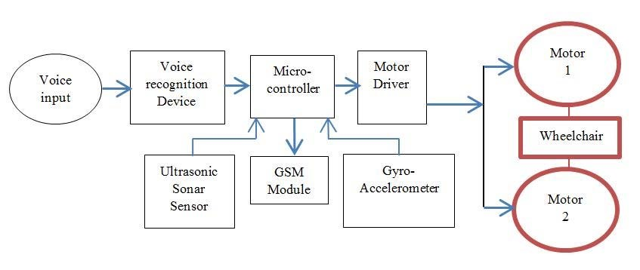

Fig. 1. Basic block diagram of the proposed system

The working functions of the main parts of the block diagram are described as below:

1. First, the audio or voice input is taken from the user and converted into electrical signal by the transducer (microphone). Then it is sent to the voice recognition device designed with Easy VR3 module and Arduino.
2. Voice commands are recorded, stored and trained in both English and Bengali language for convenience in Easy VR3. Commands used along with their explanations are mentioned below:

“Forward” or “Shamne” will drive the wheelchair forward; “Right” or “Dane” will turn the wheelchair right; “Left” or “Bame” will turn the wheelchair left; “Backward” or “Pichone” will move the wheelchair in opposite direction; “Stop” command will stop the wheelchair from moving .The voice recognition device (i.e. Easy VR 3) then processes the data and matches with the trained data and if the command matches then forwards a coded digital signal to the microcontroller.

1. Arduino Mega checks all the data coming from Easy VR3 and other ultrasonic sensors. If the voice commands are matched, then it sends an activation signal to the motor controller for controlling the motor movement to drive the wheelchair into desired direction.

The operational flow chart is given in Figure 2.

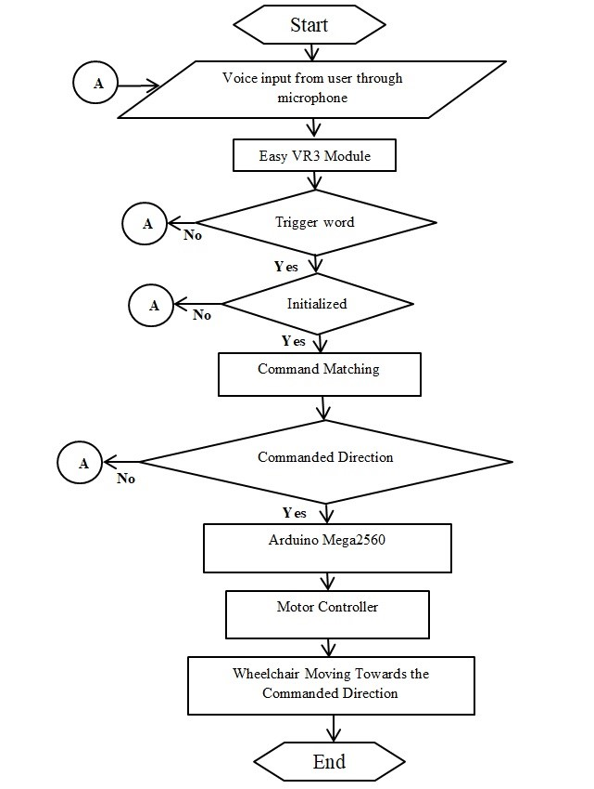

Fig.2. Operational Flow chart of the system. A is the initial state of recording the command signal.

III. DEVICES AND SENSORS USED IN THE DESIGN

A. Voice Recognition Device:

To design a small sized speech processor in comparison to the complex bulky signal processing system using laptop, we used EasyVR3 module as the stand-alone speech processor with Arduino. It is a compact device and also available as Arduino shield. It is compatible with any host device, which supports TTL logic level [12]. It has its own software, which is very user-friendly, easy to train and implement in real life application. Some other features of this device is shown as below :

1. Able to process up to 28 custom Speaker Independent (SI) command vocabularies.
2. Capable of storing up to 22 minutes of pre-recorded sounds or speech at minimum data compression rate.
3. Able to process up to 32 user-defined Speaker Dependent (SD) or Speaker verification (SV) commands, that can be trained in any language.
4. Differential audio output that directly supports 8Ω speakers.

By changing a jumper (J7) connection, it can be trained and used. To train the EasyVR3 module the jumper must be put on a connection mode named “PC”. To upload a new firmware or custom sound table it should be in “UP” position. To use it in real life application the connection must be changed to “SW” or “HW” mode [13]. The device has a feature which enables the user to use his/her native language or dialect by training. An audio output feature of the Easy VR3 can also help the user to get notified in emergency situations. B. Microcontroller:

In this design, we have used Arduino Mega2560, which is a modified form of ATMEL ATmega2560. To merge and use multiple devices together, Arduino Mega2560 was chosen which has 54 pins input/output pins, 4 UARTs, 16 analog inputs, a 16MHz oscillator. It has a Flash Memory 256 KB of which 8 KB used by bootloader, SRAM of 8 KB and EEPROM of 4 KB [13]. It can be powered by an USB connection or with an external power supply. It contains everything needed to support the microcontroller [14]. C. Motor:

In this design, 24V 250watt brushed DC motor has been chosen as it is widely used in industrial applications where the load is heavy. The chosen motor’s higher rotational speed measured in RPM can be reduced using gear mechanism to provide more staring torque. The motor has a starting torque of around 50Kg-cm operated at 12V.

1. Motor Controller

A motor controller is needed to control its rotation so that the wheelchair can move toward the direction commanded by the use. Due to continuous heating issue of MOSFET driven motor controllers and considering the safety of the patient, we used 12V relay module as motor controller. Relay is an inductive device, which can store energy in its coils that can cause damage to the low powered electronic components. Therefore, to protect the circuit, a freewheeling diode and an opto-coupler was used in the relay module so that it can be controlled by the low power microcontroller device.

1. Battery:

Two 12V 30Ah(Ampere hour) sealed lead acid rechargeable batteries were used to provide power of the whole system. They were connected in series to have 24V to supply the power to the motor.. Although this battery is little bit heavy weighted, this battery is used due to its availability and comparatively lower cost.

1. Ultrasonic sonar sensor:

Ultrasonic sonar sensors are used to provide safety for the user by detecting the presence of any obstacles to avoid collision. Sensors labeled “HC-SR04” are used in this design. The transmitter part of the sensor transmits an ultrasonic sound with a speed of around 343 m/s in the air. If there is any obstacle present then the sound is reflected back and an echo is generated, which is later captured by the receiver end of the sensor. Time taken between the transmission and receiving is then used to calculate the distance between the obstacle and the sensors positions. G. Gyro-accelerometer:

In order to keep track of the symmetrical position of the wheelchair, the MPU6050 Gyro-accelerometer is used. It has 3-axis gyro and 3-axis accelerometer built in it to provide both vertical and horizontal positions at the same time.

H. GSM module:

SIMCON SIM900A module is used in this design project to send messages to a close person or a relative of the user in emergency cases so that necessary steps can be taken immediately.

IV. SIMULATION AND EXPERIMENTATION OF THE PROPOSED

DESIGN

Simulation in computer using EDA tools is normally done before starting the hardware implementation to check the expected performance of different devices. In this design, simulation was performed whether the motor runs properly and can produce the left and right directional movement of the wheelchair according to the voice commands. The circuit was simulated using Proteus software as shown in figure3.

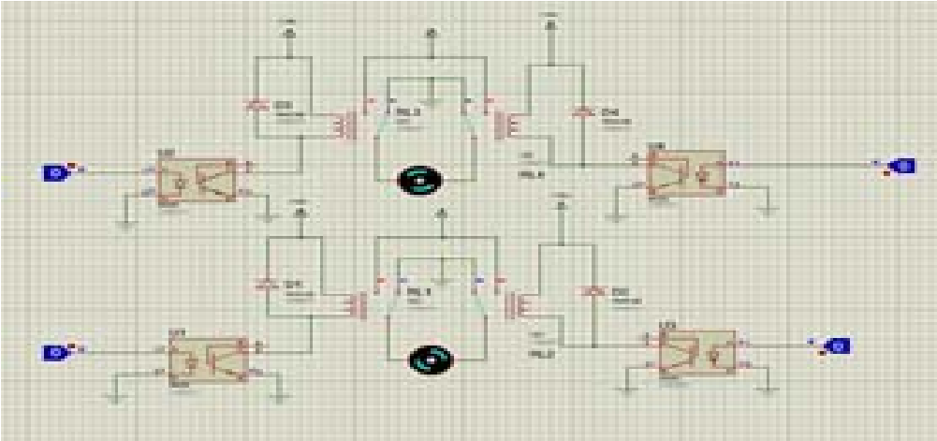

Fig. 3. Simulation of Relay motor controller circuit in Proteus software

When two motor rotates in the same direction the wheelchair will move either in the forward or backward direction. For right directional movement, only the left motors run in clockwise rotation and for the left directional movement only the right motor run in clockwise rotation. In the simulation, these rotational directions were checked by giving signals to the motor controller.

DC-DC step-down buck converter was used to provide 5V for all the discrete electronic components and 12V for the relay from the main power source of 24V.

The voice recognition module was trained in both Bengali and English directive words as shown in figure 4. It can be trained also using any language or dialect. Firstly, a trigger word **“Auvo”** was trained which enables the option to execute further commands. Every command is needed to be pronounced twice in the training session.

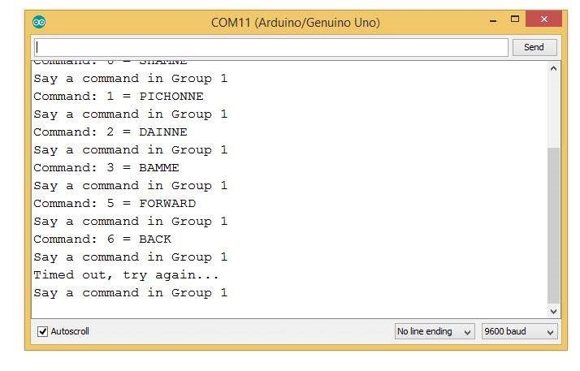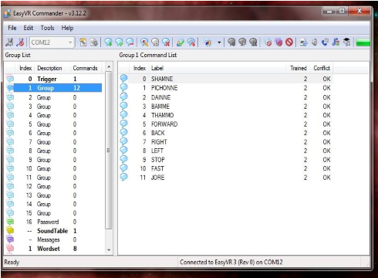

Fig. 4. Commands training in the Easy VR 3 commander software.

A market available wheelchair was used in this design for the testing purpose where the motors and the control circuit was connected to the speech processing module as shown in figure 5.

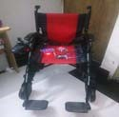

Fig. 5. Designed prototype validation

Several tests were run in home and office environment (i.e. class room, laboratory) with low noise where the developed design worked perfectly three times out of five attempts. On the contrary, while testing it in a loudly noisy area (i.e. crowded places or traffic congested areas) it was difficult to control the wheelchair sometimes. Future work is focused to make the design work in a noisy environment by additional speech processing with noise removal and classification techniques. It was possible to evade any accidents as obstacle avoidance technology was used. The wheelchair was able to carry an average weighted (~70 Kg) adult person with a nominal speed of 3.5 Km/h. The battery can give up backup for 3 hours.

1. COST ANALYSIS

The estimated cost of this design is shown in the table below. The devices which are used in this proposed design are mostly available in the regular electronics market in Bangladesh as well as throughout the world and online shops (e.g. amazon.com, techshopbd.com).

Table1: Cost analysis of the proposed automated wheelchair system design

|  |  |  |  |  |  |
| --- | --- | --- | --- | --- | --- |
| **Component**  **serial**  **number** | **Component name** | **Component Quantity** | **Price per**  **unit (TK)** | **Total cost (in**  **TK)** | **Total cost (in $)** |
| 1 | Arduino Mega2560 | 1 | 800 | 800 | 7.22 |
| 2 | EasyVR3 | 1 | 5556 | 5556 | 50 |
| 3 | Motor | 2 | 2800 | 5600 | 66 |
| 4 | 12V 30Ah Battery | 2 | 3000 | 6000 | 120 |
| 5 | GSM module | 1 | 1700 | 1700 | 11 |
| 6 | Gyro/Accelerometer | 1 | 250 | 250 | 1.17 |
| 7 | Relay Module | 2 | 300 | 600 | 12.72 |
| 8 | Ultrasonic Sonar sensor | 2 | 100 | 200 | 1.9 |
| 9 | DC-DC step-down  buck converter | 2 | 400 | 800 | 6 |
| 10 | Wheelchair | 1 | 5500 | 5500 | 78 |
| 11 | Others |  | 1200 | 1200 | 12 |
|  | Total |  |  | 30450 | 365.81 |

1. DISCUSSION AND CONCLUSION

Due to rapid technological development, more advanced user friendly electronic devices are available in more compact form than that of the previously produced ones. These developed devices are being used to improve the lifestyle of the physically disabled persons and able them to keep pace with others in the society. In this project, our developed design of the automated wheelchair has a voice recognition device, microcontroller, and GSM module for location tracking which are easily available, easier to interface with each other and their use is not very difficult. Still more work to be needed to make the design more compact by considering several issues like positioning the speech recognition and motor driver module at the most suitable position for the patient and proper balancing of the wheelchair. Finally, we believe that those people who are socially isolated or lag behind due to their physical disability will have the opportunity to move freely without any assistance like other people of the society by using their voice commands.

REFERENCES

1. WHO, “World Report on Disability - Summary,” World Rep. Disabil. 2011, no. WHO/NMH/VIP/11.01, pp. 1–23, 2011.
2. “The Maker: George Klein and the first electric wheelchair - U of T

Engineering News.” [Online]. Available:

http://news.engineering.utoronto.ca/maker-george-klein-first-electricwheelchair/. [Accessed: 30-Aug-2017].

1. R. C. Simpson, “Smart wheelchairs: A literature review,” J. Rehabil. Res. Dev., vol. 42, no. 4, p. 423, 2005.
2. Lin, Chern-Sheng & Chien-Wa, Ho & Wen-Chen, Chen & ChuangChien, Chiu & Mau-Shiun, Yeh. “Powered wheelchair controlled by eye-tracking system” Optica Applicata. 2006, Vol. 36 Issue 2/3, p401412.
3. Tsui, Chun Sing & Jia, Pei & Gan, John & Hu, Huosheng & Yuan, Kui. (2008). EMG-based Hands-Free Wheelchair Control with EOG Attention Shift Detection. Proceedings of IEEE International Conference on Robotics and Biomimetics. 1266 - 1271.

10.1109/ROBIO.2007.4522346.

1. Guin and B. B. Baishya, “Brain Controlled Wheelchair using LabVIEW,” Jan. 2013.
2. M. Mahmud, D. Hawellek, A. Bertoldo. (2010). EEG Based BrainMachine Interface for Navigation of Robotic Device. Proc. 3rd IEEE/RAS-EMBS Intl. Conf. Biomed. Robotics & Biomechatronics (BioRob’10), Tokyo, Japan, 26-29 Sept. 2010, pp. 168-172, doi: 10.1109/BIOROB.2010.5627015
3. M.S. Kaiser, Z. Chowdhury, S. Al Mamun, A. Hussain, M. Mahmud. (2016). A Neuro-Fuzzy Control System Based on Feature Extraction of Surface Electromyogram Signal for Solar-Powered Wheelchair. Cogn. Comput., 8(5): 946-954. doi: 10.1007/s12559-016-9398-4.
4. “Tongue drive wheelchair (PDF Download Available).” [Online]. Available:https://www.researchgate.net/publication/237020352_Tongue _drive_wheelchair. [Accessed: 15-Aug-2017].
5. Kathirvelan, R. Anilkumar, Z. C. Alex, and A. Fazul, “Development of low cost automatic wheelchair controlled by oral commands using standalone controlling system,” 2012 IEEE Int. Conf. Comput. Intell. Comput. Res. ICCIC 2012, 2012.
6. Skraba, R. Stojanovic, A. Zupan, A. Kolozvari, and D. Kofjac, “Speechcontrolled cloud-based wheelchair platform for disabled persons,” Microprocess. Microsyst., vol. 39, no. 8, pp. 819–828, 2015.
7. G Azam and M T Islam, “Design and Fabrication of a Voice Controlled Wheelchair for Physically Disabled People”, Department of Mechanical Engineering, CUET, International Conference on Physics Sustainable Development & Technology (ICPSDT-2015), August 19-20, 2015
8. “EasyVR 3 User Manual-VeeaR.” [Online]. Available: http:// www.veear.eu/files/EasyVR-User-Manual.pdf.
9. “Arduino Mega 2560 Rev3.” [Online]. Available: https://store.arduino.cc/usa/arduino-mega-2560-rev.